**JS201 - Class-1[Pre-class]**

*Introduction to* ***JS201*** *& Solid foundations*

**What is Javascript?**

Javascript is one of the most popular and widely used programming languages.

It's growing as fast as python.

Giants like Netflix, Walmart, and Paypal are building entire applications around Javascript.

**What can you do with Javascript?**

* Add interactivity to webpages
* Make full web/mobile apps with javascript
* Desktop applications
* Real-time networking applications
* Command-line tools
* Games
* Backend services
* Databases

**Where does Javascript code run?**

* JS was originally designed to run only in client-side **browsers**
  + every browser has a j***avascript engine*** that can execute javascript code
  + google chrome's JS engine is **V8**
  + firefox's JS engine is **SpiderMonke**y
* **Node** is a cross-platform environment; Using node we can execute Javascript code in any operating system (desktops & servers); Node uses google chrome's V8 engine to execute JS code literally anywhere.

In other words, ***browsers*** and **n*ode*** provide a runtime environment for our Javascript code.

**What is the difference between JavaScript and ECMAScript?**

ECMAScript is just a specification. Javascript is a **programming language** that conforms to the specifications.

An organization called **ECMA** is responsible for defining standards.

1997 started 2015 → ES6 (Many new features) 2016 → ES7 2017 → ES8

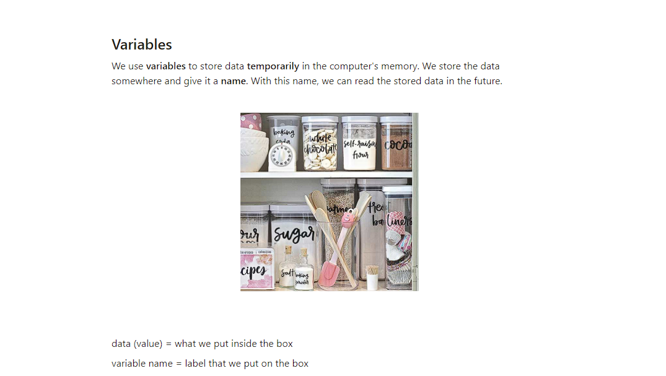

* Variable names cannot contain spaces.
* Variable names must begin with a letter, an underscore (_) or a dollar sign ($).
* Variable names can only contain letters, numbers, underscores, or dollar signs.
* Variable names are case-sensitive.
* Certain words may not be used as variable names, because they have other meanings within JavaScript.

**var, let & const**

There are three ways to declare a variable.

**What all types of values can be assigned to variables?**

**Primitives (value types)**

string

number

boolean

undefined

null

bigInt

symbol

**Non Primitives (reference types)**

object

array

function

**Dynamic Typing**

using the typeof operator to check types & change them dynamically

**Lecture**

<https://course.masaischool.com/lectures/40753>